Power Query – M Functions
Import Data
CSV – Single File
= Table.PromoteHeaders(
Csv.Document(
File.Contents(Base_Path & "Data Folder\Dataset.csv"),
[Delimiter=",", Columns=5]
)
)

CSV – Multiple Files
let
Source = Folder.Files(Base_Path & "Data Folder "),
Combined_Data =
Table.Combine(
Table.AddColumn(
Source,
"Data",
each
Table.PromoteHeaders(
Csv.Document(
[Content],
[Delimiter = ",", Encoding = 65001, QuoteStyle = QuoteStyle.Csv]
)
)
)[Data]
)
in
Combined_Data

Excel – Single File
= Table.Combine(
List.Transform(
Excel.Workbook(
File.Contents(base_folder & "\Dataset.xlsx"), null, true
)[Data],
each Table.PromoteHeaders(_)
)
)

Excel – Multiple Files
let
Source = Folder.Files(base_folder & "\Healthbay Data"),
Combined_Data =
Table.AddColumn(
Source,
"Data",
each Table.PromoteHeaders(
Table.Combine(
Table.SelectRows(Excel.Workbook([Content], null, true), each [Hidden]=false and [Kind]="Sheet")[Data]
)
)
)
in
Combined_Data

Previous Row
fx_prevrow
= (tbl as table, column as text, new_col as text) as table =>
let
prevrow_index = Table.AddIndexColumn(tbl, new_col, 0, 1, type number),
currentrow_list = Table.Column(prevrow_index, column),
previousrow_value = Table.TransformColumns(prevrow_index, {{ new_col, each try currentrow_list{_ -1} otherwise null}})
in
previousrow_value

Steps to use it
1. Right on a step in right side pane > Insert step after
2. Type " =fx_previousrow(prev_step_name, column_name, new_column name) in formula bar
{ eg : fx_prevrow( Source, "Time", "Time1") } - It will create a new column [Time1] with previous row value

Ageing Bucket – Using Function
Function for Ageing buckets
fx_ageing
= (from_date as date) =>
let
Age = Number.From(current_date – from_date),
Bins = {{"<= 45 days", 0, 45}, {"46-60 days", 46, 60}, {"61-90 days", 61, 90}, {" 91-140 days", 91, 140},{">= 141 days", 141,null}},
result = List.First(List.Select(Bins, each if _{2} = null then Age >= _{1} else Age >= _{1} and Age <= _{2})),
aging_tag = if Age < 0 then null else result{0}
in
aging_tag

Using function to add a column for ageing tag in the dataset
Ageing Tag
= Table.AddColumn(
Source,
"Ageing Tag",
each fx_ageing([Date]),
type text
)

Lastest Records from Duplicate Rows
- Sometimes, the lookup dataset may have duplicate rows with different dates for a same values in a key column which is not usable for lookup values into main dataset.
- So, we need to pick a rows with latest date based on a key column

CODE :
let
Sorted_Rows = Table.Sort(Source,{{"ID", Order.Ascending}, {"Date", Order.Descending}}),
Grouped_Rows = Table.Group(Sorted_Rows, {"ID"}, {{"Count", each Table.AddIndexColumn(_, "DupFindder",1,1)}}),
Latest_Rows = Table.SelectRows(Table.Combine(Table.SelectColumns(Grouped_Rows,{"Count"})[Count]),each ([DupFinder] = 1)),
Removed_DupFinder = Table.RemoveColumns(Latest_Rows,{"Dup Find"})
in
RemovedColumns

Removing Extra Spaces in value
- Sometimes, a text in a column has extra spaces between words.
- So, we need a function to remove all the extra spaces from the text in each row of the column.

Function to RemoveSpaces
fx_removespaces
= (InputText as text) => Text.Combine ( List.Select ( Text.Split ( Text.Trim ( InputText ) , " " ) , each _ <> "" ) , " " )

CODE :
= Table.TransformColumns ( Source, { { "Name" , each fx_removespaces(_) } } )
Table.TransformColumns
- Used to apply an action or calculation to multiple columns using single M-function

Different action or calculation on mentioned columns
= Table.TransformColumns(
Source,
{
{"Speciality", each Text.Upper(Text.Trim(_)), type text},
{"ProviderName", each if Text.Start(_,4) = "Dr. " then _ else "Dr. " & _, type text}
}
)

Same action or calculation on mentioned columns
= Table.TransformColumns(
InstanceColumnAdded,
List.Transform(
{"Name","Email", "Country", "State", "Address"},
each {_, each Text.Proper(_), type text}
)
)

Skip starting rows dynamically
- Sometimes, an Excel workbook has multiple sheets where the actual data starts from different rows in each sheet.
- So, we need to dynamically get the actual data from each sheet.

Function to Skip Rows
fx_Header_row
= (tbl as table) =>
let
Header_Index = Table.AddIndexColumn(tbl, "Index", 1,1, type number),
Header_Row = Table.SelectRows(Header_Index, each List.Contains({"file name"}, Text.Lower(Text.From([Column1])))),
Header_Position = List.Max(Header_Row[Index]),
Rem_Rows_Bef_Header = Table.Skip(Header_Index, each [Index] <> Header_Position),
Final_Data = Table.PromoteHeaders(Rem_Rows_Bef_Header)
in
Final_Data

Code for skipping rows before header row
let
Source = Folder.Files(Folder_Path & "\Data Folder"),
AddData = Table.AddColumn(Source, "Data", each Excel.Workbook([Content], null, true)),
ExpandData = Table.ExpandTableColumn(AddData, "Data", {"Name", "Data", "Hidden"}, {"Sheet Name", "Data", "Hidden"}),
FilteredSheets = Table.SelectRows(ExpandData, each [Hidden] = false),
AddProperData = Table.AddColumn(FilteredSheets, "Proper Data", each fx_Header_row([Data])),
RemoveOtherColumns = Table.SelectColumns(AddProperData, {"Sheet Name", "Proper Data"}),
Expanded_Data =
Table.ExpandTableColumn(
RemoveOtherColumns,
"Proper Data",
{
"File Name", "Deposit Date", "Transfer Date", "Extraction Level", "Format", "Payer", "Check/EFT/CC No",
"Total Check Amt", "PLB Amt", "Amount Posted", "Amount Left to Post", "Downloaded Date", "Downloaded By"
}
)
in
Expanded_Data

Removing Extra Spaces in value
- Sometimes, a text in a column has extra spaces between words.
- So, we need a function to remove all the extra spaces from the text in each row of the column.

Function to RemoveSpaces
fx_removespaces
= (InputText as text) => Text.Combine(List.Select(Text.Split(Text.Trim(InputText), " "),each _ <> "")," ")

CODE :
= Table.TransformColumns(Source, {{"Name", each fx_removespaces(_)}})

Replace full value based on Sub text match
Sometimes, we need to replace a whole value of a rows in a column based on sub text.

Main_Table :  Names  My Name is Arav  My Name is Arun  My Name is Prem  Kumar is an Artist  Arvind | Replacing_Table :  Old Value New Value  Arav Emp1  Arun Emp2  Prem Emp3  Kumar Emp4  Arvind Emp5

Replace only the sub text if the sub-text found
let
SourceTable = Main_Table,
ReplaceTable = Replace_Table,
ReplacedSubText =
let
SourceTable = Main_Table,
ReplaceTable = Replace_Table,
ReplaceText =
Table.AddColumn(
SourceTable,
"Category",
each
List.Accumulate(
Replace_Table[Old Value],
[Names],
(name, old) =>
if Text.Contains(name, old, Comparer.OrdinalIgnoreCase)
then Text.Replace(
name,
old,
Replace_Table{List.PositionOf(Replace_Table[Old Value], old)}[New Value]
)
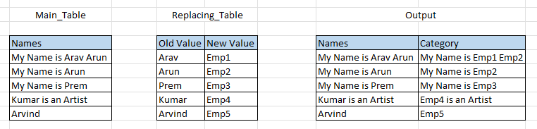
else name
)
)
in
ReplaceText
in
ReplacedSubText

Replace Entire value if a sub text found
let
SourceTable = Main_Table,
ReplaceTable = Replacing_Table,
ReplacedWholeText =
Table.AddColumn(
SourceTable,
"Modified",
each
let
matches = List.Select(ReplaceTable[Old Value], (old) => Text.Contains([Names], old, Comparer.OrdinalIgnoreCase)),
replacement = if List.Count(matches) > 0
then ReplaceTable{List.PositionOf(ReplaceTable[Old Value], matches{0})}[New Value]
else [Names]
in
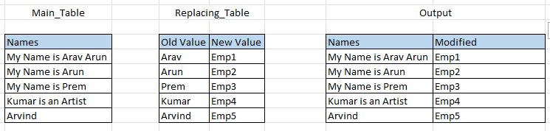
replacement
)
in
ReplacedWholeText

